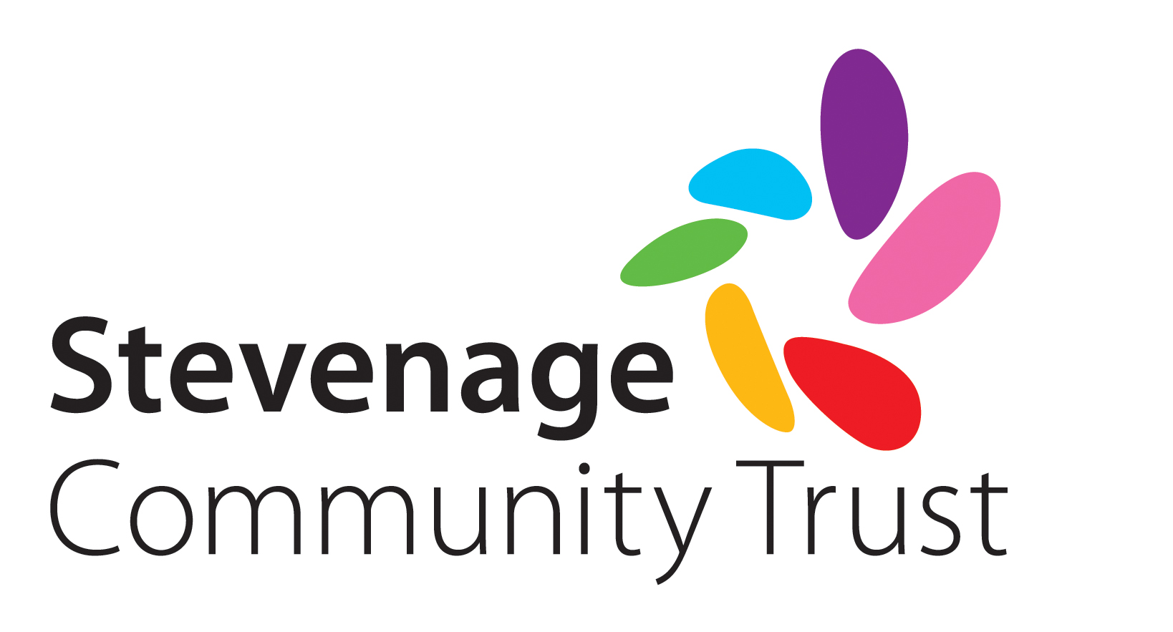
Grant Monitoring Form

SECTION 1: FINANCIAL INFORMATION

Name or group / organisation
Amount awarded | £
Date of award (mm/yy)
Has the entire grant been spent? | Yes / no (if no, please explain why)
Please provide a breakdown of how the funds have been allocated

SECTION 2: IMPACT

How has the grant benefitted your organisation?

How has the grant benefitted individuals or communities in Stevenage and/or the surrounding villages?
Approximately how many people from Stevenage and the surrounding villages will benefit from the grant?

SECTION 3: PUBLICITY

Did Stevenage Community Trust receive any public acknowledgements for this funding in the local press/ newsletters/website/annual report/other? (Please provide details and attach copies when returning this form)

We rely on personal feedback from our grant recipients to attract new donors and retain existing supporters who make our grant giving possible. Please could you therefore provide a short ‘thank you’ explaining what you have been able to achieve with this funding and how it has made a difference to your organisation and local people.

Name: Date:

Once complete, please return to: Stevenage Community Trust, Stewart House, Primett Road, Stevenage, Herts, SG1 3EE or email to grants@stevenagecommunitytrust.org

